**ABSTRACT**

**GoGigs** is Freelancing Platform - Empowering Talent, Connecting Opportunities

The abstract presents an overview of GoGigs, a dynamic and innovative freelancing website designed to revolutionize the way talented individuals connect with rewarding opportunities. GoGigs serves as an online marketplace where businesses, startups, and individuals can access a diverse pool of skilled freelancers to accomplish their projects and tasks efficiently.

GoGigs stands apart with its user-friendly interface, streamlined processes, and emphasis on skill diversity. Freelancers from various domains, such as web development, graphic design, content writing, digital marketing, and more, converge on GoGigs, enabling businesses to find the perfect match for their specific requirements.

**Introduction**

**GoGigs: Freelancing Website**

It is an online website in which clients and freelancers can register themselves online and browse the gigs cards. This website provides the work for the freelancers required for a project, with the number of works to choose from helping the freelancer/ client to access at their convenience and place online.

Earlier it was time-consuming as the client had to go look-out for freelancer with different prices and relatively at a different place for better affordable rates. Now it can all done online without much time-consuming. GoGig's user-friendly approach makes it accessible to all.

**AIM**

This online application aims to provide freelancing jobs. This proposed application helps clients and freelancers to choose the right work with familiar expertise or to have right person for theirs Gigs.

**Benefits**

Scope is the sum of deliverables and services to be provided in the project. The project is developed to the help freelancers to work on the required product at their convenient in a every and accurate manner. It makes sure that the information relating to each and every part of the input from the client is up-to-date and accurate that help the client to save time and money.

**System analysis**

**Initial Study**

System analysis is the most important stage in the System Development Life Cycle. System analysis is a process of designing computer software to serve the needs of users i.e., to provide comp software. It is an activity that encompasses most of the tasks of computer system engineering. Understanding the situation and problems of users and then finding methods to solve them is the main activity in the system analysis.

IDENTIFICATION OF NEEDS HAS TWO STEPS:

* Request Clarification.
* Fact- finding techniques.

**REQUEST CLARIFICATION:**

Before any system investigation the project request must be examined to determine what the originator/organization wants. Before any further steps project request must be clearly made and must be noted down.

**FACT FINDING TECHNIQUES:**

It is a specific method that analysis use for collection data about requirements is called fact finding technique. It helps to ensure and accurate and comprehensive investigations these include.

**REQUIREMENT ANALYSIS:**

It provides the appropriate mechanism for understanding what the customer wants, analyzing needs, and accessing feasibility, negotiating the reasonable solution, specifying the solution unambiguously, validating the specification and managing the requirements.

**REQUIREMENT SPECIFICATION:**

The following is the list of minimum hardware and software requirements that are needed to run this project.

**As the requirement analysis activity commences the following**

* Too many defects some slipping without proper information.
* Reduces productivity due to redundant effort.
* Defects should be posted efficiently.
* System which is user friendly.
* Need to track progress and measure response time.
* Shorter release cycle for each project due to market pressure.
* Delay in release of project.

**User Requirement Specification**

The following is the list of minimum hardware and software requirements that are needed to run the project.

**Client side:**

|  |  |
| --- | --- |
| **Operating System** | Windows 10 |
| **Processor** | i3 processor and above |
| **RAM** | 1GB or more |
| **Network Card** | TCP/IP |

**Sever side:**

|  |  |
| --- | --- |
| **Operating System** | Windows 10 |
| **Processor** | i3 processor and above |
| **RAM** | 1GB and above |
| **Network Card** | TCP/IP |

**FEASIBILITYSTUDY**

**FEASIBILITY REPORT:**

Whenever we design a new system, normally the management will ask for a feasibility report of the new system. The management wants to know the technicalities and cost involved in creation of new system.

* Technical feasibility
* Economic feasibility
* Physical feasibility
* Operational feasibility
* Time and resource feasibility

**TECHNICAL FEASIBILITY:**

Technical feasibility involves study to establish the technical capability of the system being created to accomplish all requirements to the user. The system should be capable of handling the proposed volume of data and provide users and operating environment to increase their efficiency.

For example, system should be capable of handling the proposed volume of data and provide users.

**ECONOMIC FEASIBILITY:**

Economic feasibility involves study to establish the cost benefit analysis. Money spent on the system must be recorded in the form of benefit from the system. The benefits are of two types:

**Tangible benefits:**

* + Saving man labor to do tedious tasks saves time.

**Intangible benefits**

* + Improves the quality of organization.

**PHYSICAL FEASIBILITY:**

It involves study to establish the time responses of the new system being created. For e.g., if the new system takes more than one day to prepare crucial finance statement for the management, wherever it was required in an hour, the system fails to provide the same.

It should be clearly established that the new system requirements in the form of time responses would be completely met with. It may call for increase in cost. If the required cost is sacrificed then the purpose of the new system may not be achieved even if it was found to be technically feasible.

**OPERATIONAL FEASIBILITY:**

A system can be technically feasible and still not be implementable. The organization also has the will to implemented it. Management must actively support development of the system. It is a measure of how well a proposed system solves the problems, and takes a advantages of the opportunities identified during scope definition and how it satisfy the requirements identified in the requirements analysis phases of system development.

**TIME AND RESOURCE FEASIBLITY:**

It is also an essential part of a feasibility study. It includes questions regarding time required to complete the project, type and number of resources required and dependent factors. It also takes care whether the project is interrupting any current business activity so it takes care of optimum utilization of the resources available.

**IDENTIFICATION OF NEEDS**

**EXISTING SYSTEM:** Not many availabilities of freelance portals.

**DRAWBACKS:**

1**. Redundancy**:

Manual records tend to contain data which are redundant. This is because Normalization followed is consistent data base is missing feature in manual records.

2. **Inconsistency**:

Because of redundant data, there is no consistency in the data.

3. **Time Consuming**:

Maintaining each client and freelance data with much number of fields is a tedious process and takes more time to retrieve back.

4. **Improper Validation**:

There are many cases where validation is to be performed between the existing data and yet to be entered data.

5. **Tedious**:

A client and freelance data base go through many numbers of updates each day which is hard to maintain in registers.

**PROPOSED SYSTEM:**

The developed system overcomes all the above listed drawbacks.

* Client, Freelancer and Administrator information is maintained in normalized database instead of manual records.
* This feature helps in maintaining database which is consistent, not redundant and easily maintainable.
* This system helps in client to go through multiple freelancer and type of work required for their projects
* The three main users are
  + Administrator
  + Client
  + Freelancer

**ADVANTAGES OF PROPOSED SYSTEM**

* Easily can view and update particular card.
* Easy to search information of particular card.
* No chances of losing information.
* Client/freelancers information is maintained properly, secure and safe.
* Reduces paper and a bit of manual work.
* Easily store large volume of data.
* Easy to retrieve and accesses the data
* Access to global pool talents.
* Wide range of skills
* Security is provided by giving username & password.
* All the data is maintained in only one database.

**Preliminary Investigation:**

Once project developer identifies the need for the project, she/he should have a clear concept about what is to be done in the project. Whether the project should be improved or modified from the existing system or the developer should build a completely a new system. An initial investigation conducted on the project **“GoGigs: Freelancing Website”** is described first, we should understand what major problem are going to arise in maintaining record manually.

Preliminary Investigation basically refers to the collection of information that guides the management of an organization to evaluate the merits and demerits of the project request and make an informed judgment about the feasibility of the proposed system. This sort of investigation provides us with a thorough picture of the kind of software and hardware requirements which are most feasible for the system, plus the environment in which the entire project has to be installed and made operational.

**Interview:**

This method is used to collect the information from groups or individuals. Analyst selects the people who are related with the system for the interview. In this method the analyst sits face to face with the people and records their responses. The interviewer must plan in advance the types of questions he/she is going to ask and should be ready to answer any type of question. He should also choose a suitable place and time which will be comfortable for the respondent

**Questionnaire:**

It is the technique used to extract information from number of people. This method can be adopted and used only by a skillful analyst. The Questionnaire consists of series of questions framed together in a logical manner. The questions are simple, clear and to the point. This method is very useful for attaining information from people who are concerned with the usage of the system and who are living in different countries. The Questionnaire can be mailed or sent to people by post. This is the cheapest source of fact finding.

**On Site Observation:**

Unlike the other fact-finding techniques, in this method the analyst himself visits the organization and observes and understand the flow of documents, working of the existing system, the users of the system etc. For this method to be adopted it takes an analyst to perform this job as he knows which points should be noticed and highlighted. An analyst may observe the unwanted things as well and simply cause delay in the development of the new system.

**HARDWARE AND SOFTWARE REQUIREMENTS**

**Hardware requirement:**

* Processor: windows 7 above.
* Primary Memory: 2GB RAM minimum.
* Secondary Memory:4GB Hard Disk.
* Input Device: Mouse keyboard.
* Client: Any internet connect device.

**Software Requirement:**

Requirement for developing application

* Operating System: Windows 10
* Front End: HTML, Tailwind-CSS, NextJS, JavaScript
* Back End Database server: MongoDB Server, NextJS

**DESIGN ANDIMPLEMENTATIONOF THE PROJECT**

**SYSTEM DESIGN:**

Design is the key phase of any project. It is first step in moving from the problem domain to the solution domain. The input to the design phase is the specification of the system to be designed. The output of the top-level design is the architecture design, or the system design for the software system to be built. The most challenging, creative and difficult phase of the System Development Life Cycle is the ‘System Design’. The term System Design describes the design of the final system. Designing a system is like laying foundation before building any system. It is like a blue print for any construction. It refers to the technical specification that will be applied in implementing the proposed system. System Design acts as base for the system that is going to be built. Building system without the system design should be avoided. There are several ways of designing a system. A design should be very clear, verifiable, complete, traceable, efficient and simple.

**ARCHITECTURE DIAGRAM:**

The architectural design defines the relationship among major structural element of the program. Architecture diagram shows the relationship between different components of system. This diagram helps to understand the overall concept of system.

**DESIGN:**

The most challenging phase of the system life cycle is system design. The term design describes a final system and the process by which it is developed. It refers to the technical specifications that will be applied implementing the candidate system. It also includes the constructions that will be program and program testing. System design is a solution a “how to “approach the creation of new system. This important phase is composed of several steps. It provides understanding and procedural details necessary for implementing the system recommended in the feasibility study Emphasis on translating the performance into design specifications. The first step is to determine how the output is to produced and into what format. Samples of the output and input are also presented. Second, input data and master files (database) have to be designed, meet the requirements of the proposed output. The operational (proposing) phases are handled through program construct on and testing, including a list of programs needed to meet the systems objectives and to complete documentation.

Finally, details related to justification of the system and an Estimate of the impact of the candidate system on the user and the Organization are documented and evaluated by management as a step toward implementation.

**The basic steps in designing are:**

* Input Design
* Output Design
* Database Design
* Process Design

**Input Design:**

Inaccurate input data are the most common cause of errors in data processing. Errors entered by data entry operators can be controlled by input design. Input design is the process of converting user – originated inputs to a computer – based format in the system design phase. The Expanded data flow diagram identifies data flows. Data stores, sources and destinations. A system flowchart specifies master files (database), Transaction files and computer programs.

**Input Media:**

In this project earlier stages identified the data that is input to the transactions. The next step is what media should be used for the input. There are three approaches for data entry with forms menu based, formatted forms, and prompts. We adopted the formatted form approach for entering data. A formatted form is a preprinted form or a template that request the user to enter the data in appropriate locations. It is a fill in-blank type. The form is flashed on the screen as a unit. The cursor is usually positioned at the first blank. After the user responds by filing in the appropriate information, the cursor automatically moves to the next line, and so on until the form is completed.

**Form types:**

There are four types classified by what it does in the system. They are: action forms-to perform some extraction such as storing, modifying, and deleting data searching memory forms- to perform extraction and display operations on existing historical data, and report forms to generate decision support data from existing records. We used as output forms, as an input media we used both action and memory forms in combination.

**Form Layout:**

When form is designed a list prepared of all the items to be included on the form and the maximum space to be reserved. The form user to make sure it has the required details should check the list

* Title
* Data zoning
* Rules and captions

**Design considerations:**

In designing these forms, we taken care several attributes that are mentioned below:

* Identification and wording – Form titles and labels.
* Maximum readability and use – Legible intelligible uncomplicated and space.
* Physical factors – Composition, color, layout.
* Order of data items – Logical sequence, data relation.
* Ease of data entry – Field positions
* Size and arrangement- Size, storing, filing and space for signs.
* Use of instructions – Online help for data entry, status information.

Computer output is the most important and direct source of information to the user. Efficient, intelligible output design should improve the system’s relationship with the user and help in decision making. A major form is hard copy from the printer.

Output from computer system is required to communicate the result of processing to users. Designing computer output should process in an organized and well- thought manner.

The right output must be developed while ensuring that each Output element is designed so that the user will find the system easy to use effectively.

The term -output applies to any information by an information system, whether printed or displayed. While designing computer outputs the following steps have to be pursued. In addition to deciding on the output device, the system analyst must consider the print format and the editing for the final printout. The task of output preparation is critical, requiring skill and ability to align user requirements with the capabilities of the system in operation. The design considerations we have followed while designing output are:

* Name or title
* Space and arrangement
* Headers and Footer

In online applications, the layout sheet for displayed output is similar to the layout chart used for designing input. In these cases, the output forms are similar to the input forms. Other type of applications output forms like reports used to make decisions must be designed carefully.

**LANGUAGES USED**

**HTML:**

**Introduction:**

HTML is a Major language of the Internet’s World Wide Web. Web sites and web pages are written in HTML the World Wide Web is a collection of linked documents or a page on millions of computers spread over the entire Internet.HTML defines their appearance and layout and more importantly creates the links to other documents.

The global publishing format of the Internet is HTML. It allows authors to use not only text but also format that text with headings, lists and tables, and to include still images, video and sound within the text. The language also tells you how to make a document with the other document on your local system, the World Wide Web and other Internet resources such as FTP.

Unlike Word Processors and Desktop publishing, the Webpage authors writes instructions called tags which tell the browser how to read the document. Really this is much the same as using world Processor. The other difference is that all the files are saved with an HTML or HTML file extension.

Reader can access pages of information from anywhere in the World at the click of mouse button. Information can be used for entering data as the front-end for commercial transactions.

**FEATURES OF HTML:**

* It is not a Programming Language.
* It’s not a Data Description Language.
* It is Simple to Understand and Implement.
* HTML constructs are very easy to comprehend, and can be used effectively by anybody.
* The Methodology is used by HTML to Markup information is independent. Of its representation on a particular hardware or software architecture.

HTML syntax is World Wide Standard

.

**Tailwind CSS**

It is basically a Utility first CSS framework for building rapid custom UI. It is a highly customizable, low-level CSS framework that gives you all of the building blocks that you need. Also, it is a cool way to write inline styling and achieve an awesome interface without writing a single line of your own CSS. Tailwind has come with inbuilt a lot of features and styles for users to choose from and is also used to reduce the tendency of writing CSS code and create a beautiful custom UI. It will help you to overcome the complicated task. Tailwind CSS creates small utilities with a defined set of options enabling easy integration of existing classes directly into the HTML code.

**Advantages:**

* Highly Customizable.
* Enables building complex responsive layout.
* Responsive and development is easy.
* Component’s creation is easy.

**Disadvantages:**

* There are missing headers, and navigation components.
* It takes time to learn how to implement inbuilt classes.

**JavaScript (JS):**

JavaScript (JS) is a high-level, interpreted programming language primarily used for adding interactivity and dynamic content to websites. It was created by Brendan Eich in 1995 and quickly became an essential part of web development. JS allows developers to manipulate the Document Object Model (DOM) of a webpage, enabling actions like user input handling, content updates, and animations. With its easy-to-learn syntax and cross-platform compatibility, JavaScript has become one of the most popular programming languages worldwide. It is not only used for front-end web development but also for back-end development, thanks to platforms like Node.js. JavaScript's versatility, vast ecosystem of libraries and frameworks, and continuous evolution make it a crucial tool in building modern, interactive, and responsive web applications

**NextJS:**

Next.js also offers powerful data fetching capabilities, including server-side data fetching, client-side data fetching, and incremental static regeneration. This makes it easy for developers to handle data from various sources, ensuring optimal performance and data freshness.

The framework's robust ecosystem provides a wide range of plugins and extensions, making it easy to integrate with popular tools, libraries, and services. Additionally, Next.js has extensive support for modern JavaScript features, making it future-proof and adaptable to the evolving needs of web development.

The built-in development server and production optimization tools streamline the development process and help deliver optimized applications with minimal effort. Its easy deployment options make it convenient for hosting on various platforms, including cloud services and static hosting platforms.

Next.js is backed by Vercel, a cloud platform for serverless deployment, which ensures seamless integration and deployment of Next.js applications. The combination of Next.js and Vercel provides a powerful, full-stack development solution for creating high-performance web applications.

**DATABASE:**

A database is a collection of related information. Defining a database involves specifying the data type, attributes and constraints for the data to be stored.

**MongoDB:**

MongoDB is an open-source, NoSQL database management system. It is classified as a document-based database, which means it stores data in flexible, JSON-like documents with dynamic schemas. MongoDB is designed to handle unstructured or semi-structured data, making it well-suited for modern web applications and other data-intensive projects.

MongoDB is widely used in various industries and for different use cases, such as content management systems, e-commerce platforms, social networks, IoT applications, big data analytics, and more. Its flexibility, scalability, and developer-friendly features have made it a popular choice among developers and organizations seeking modern and agile database solutions.

**Database Design:**

Database design is the process of developing database structures. To hold data to cater to user requirements. The final design must satisfy user needs in terms of completeness, integrity, performance and other factors. For a large enterprise, the database design will turn out to be an extremely complex task leaving a lot to the skill assisted techniques are available to facilitate database design.

The primary input to the database design process is the organization’s statement of requirements. Poor definition of these requirements is a major cause of poor database design, resulting in database of limited scope and utilities which are usable to adapt to change.

The major step in database design is to identify the entities and relationship that reflects the organization’s data naturally. The objective of this step is to specify conceptual structure of the data and is often referred to as data modeling.

There are several methodologies to model the data logically. We adopted ER Modeling as our data modeling technique. ER Mode is technique for analysis and logical modeling of systems data requirement. It uses three basic concepts: Entities, Attributes, Relations.

**Process Design:**

Structure design is data flow-based methodologies; the approach begins with a system specification that identifies inputs and outputs and describes the functional aspects of the system. The next step is the definition of the modules the functional aspects of the system. The next step is the definition of the modules and their relationships to one another in a form called a structure chart using a data dictionary, DFD, and other structured tools.

.

**Types of Design:**

* **Data Design:**

It is described the structure that resides within the software.

* **Architecture Design:**

It uses information flow characteristic and maps them into the program structure. Transformation mapping method is applied to exhibit distinct boundaries between incoming and outgoing data.

**SOFTWARE ENGINEERING PARADIGM APPLIED**

**Software Engineering Paradigm Applied:**

This document plays a vital role in the development of (SDLC) as it describes the complete requirements of the system. It means for use by developers and will be the basic during testing phase. Any changes made to the requirements in the future will have to go through formal changes approval process.

The waterfall model is a sequential design process, often used in software development processes, in which progress is seen as following steadily downwards (like a water) though the phase of conception, initiation, analysis, design, construction, testing, production/implementation, and maintenance.

The first formal description of the waterfall model is often cited as a 1970 article by Winston W. Royce, although Royce did not use the term “waterfall” in this article. Royce presented this model as an example of a flawed, non-working model. This, in fact, is how the term is generally used in writing about software development practice.

The waterfall development model originates in the manufacturing and construction industries; highly structured physical environments in which after the fact changes are prohibitively costly, if not possible. Since no formal software –oriented model was adapted for software development.

The waterfall model shows a process, where development are to follow these phase in order:

* Requirement’s specification (Requirement analysis)
* Software design
* Implementation and integration
* Testing (or Validation)
* Development (or installation)
* Maintenance

**Requirements** – Defines needed information, functions, behavior, performance and interface.

**Design** – Data structure, software architecture, interface representation algorithmic details.

**Implementation** -- source code, database, user documentation, testing.

**The following diagram shows how a waterfall model acts like:**

**REQUIREMENTS**

**SOFTWARE DESIGN**

**IMPLEMENTATION**

**TESTING**

**DEPLOYMENT**

**MAINTENANCE**

**Advantages:**

* Easy to understand, easy to use.
* Provides structure to inexperienced staff.
* Milestones are well understood.
* Set requirement stability.
* Good for management controls (plan, staff, and track).
* Works well when quality is more important than cost or schedule

**DATAFLOW DIAGRAMS AND ENTITY RELATIONSHIP DIAGRAM**

**Data Flow Diagrams:**

A Data Flow Diagram illustrates the flow of data through the system. A system may be an organization, a manual procedure, a software system, or a combination of these. Specific symbols are used in designing the data flow diagrams. Data Flow Diagrams represent the following objects of the real world through the symbols.

**Processes:**

These are the tasks that occur in the real world. These are represented using rounded rectangles in Data Flow Diagrams.

**Files and Data Store:**

The repository of data, which is used to store records. These are represented by open rectangles.

**External Entities:**

External Entities are outside the system but they either supply input to the system or use the system output. These are represented by rectangles in Data Flow Diagrams.

**Data Flow:**

These represent the direction of the flow of data between the processes and entities. The Data Flow may be unidirectional or Bidirectional. The lines with arrow heads represent the Data Flows.

**Data Flow Diagrams:**

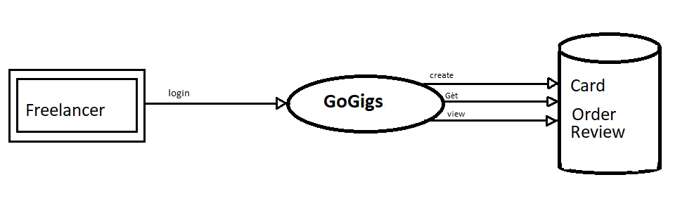

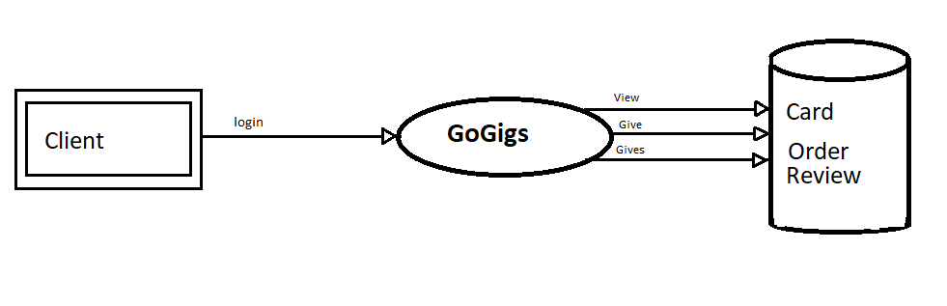

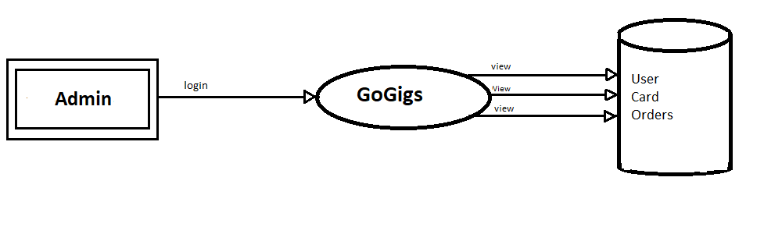

**Second Level DFD’s:**

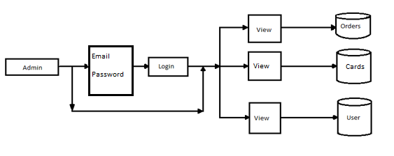

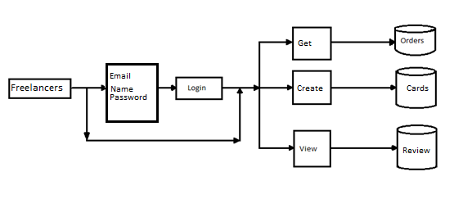

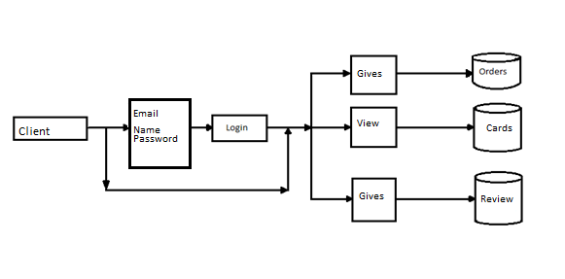

**Entity Relationship diagram (ER diagram) :**

An ER- diagram is a data modeling technique that graphically illustrates an information systems entities and relationships between those entities. An ER-diagram is a conceptual and representational model of data used to represent the entity framework infrastructure.

**The elements of an ER –Diagram are:**

* **Entities.**
* **Relationships.**
* **Attributes.**

**Entity:** An entity may be an object with a physical existence, house or employee or it may be an object with a conceptual existence.

**Relationships:** A relationship is how the data is shared between entities there are three types of relationship between entities.

* One-to-one
* One-to-many
* Many-to-many

**Attributes:** Each entity has its attributes that is the particular properties that describes it. There are five types of attributes associated with entity.

* composite verses simple(atomic) attribute.
* Single verses multi valued attributes.
* Stored verses derived attributes.
* Null values.
* Complex attribute.

**Notations for ER- diagram:**

|  |  |
| --- | --- |
| **Symbols** | **Meaning** |
|  | Entity |
|  | Weak entity |
|  | Relationships |
|  | Identifying relationship |
|  | Attributes |
|  | Derived attributes |
|  | Multivalve attributes |
|  | Composite attributes |
| E2  E1  R | Total partition of E2 to R |
| E2  R  E1 | Cardinality ratio for E1, E2 in R |
| (Min, max)  E  R | Structural constraint (min, max) on partition of E in R |

**ER Diagram of GoGigs:**

**User ER Diagram:**

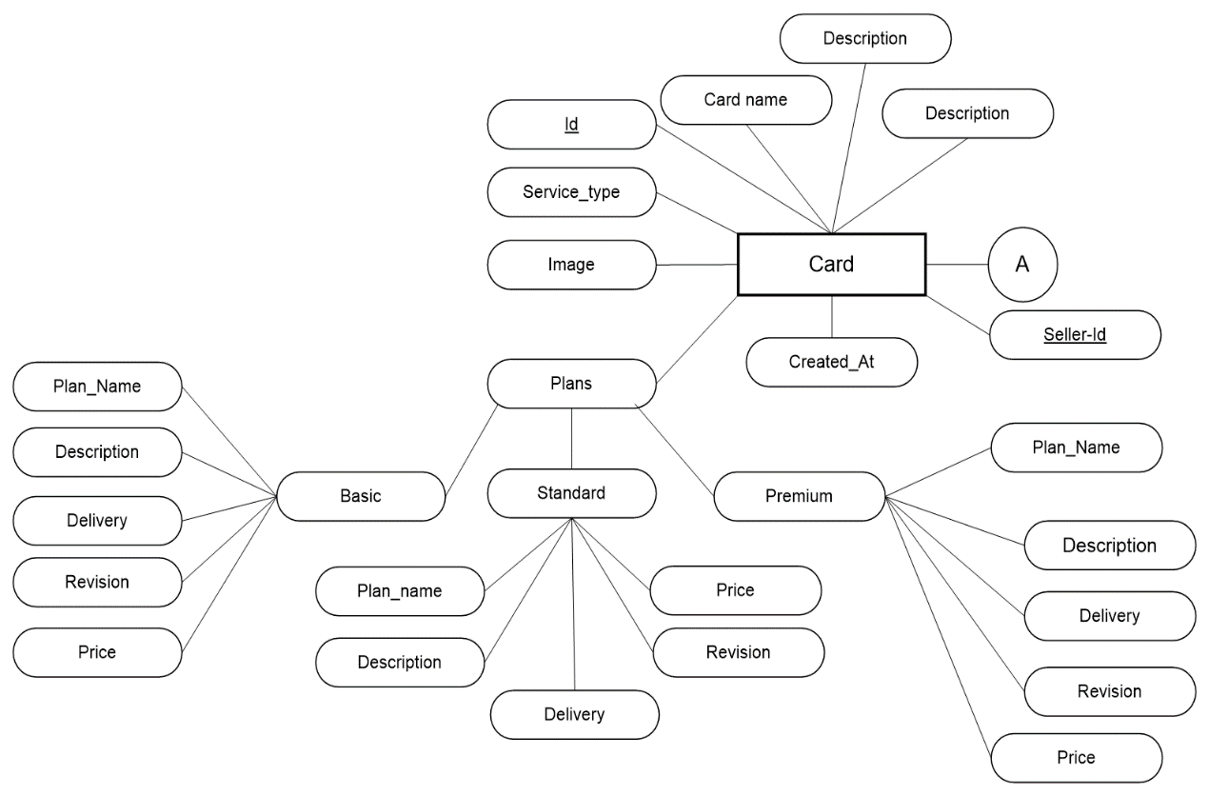

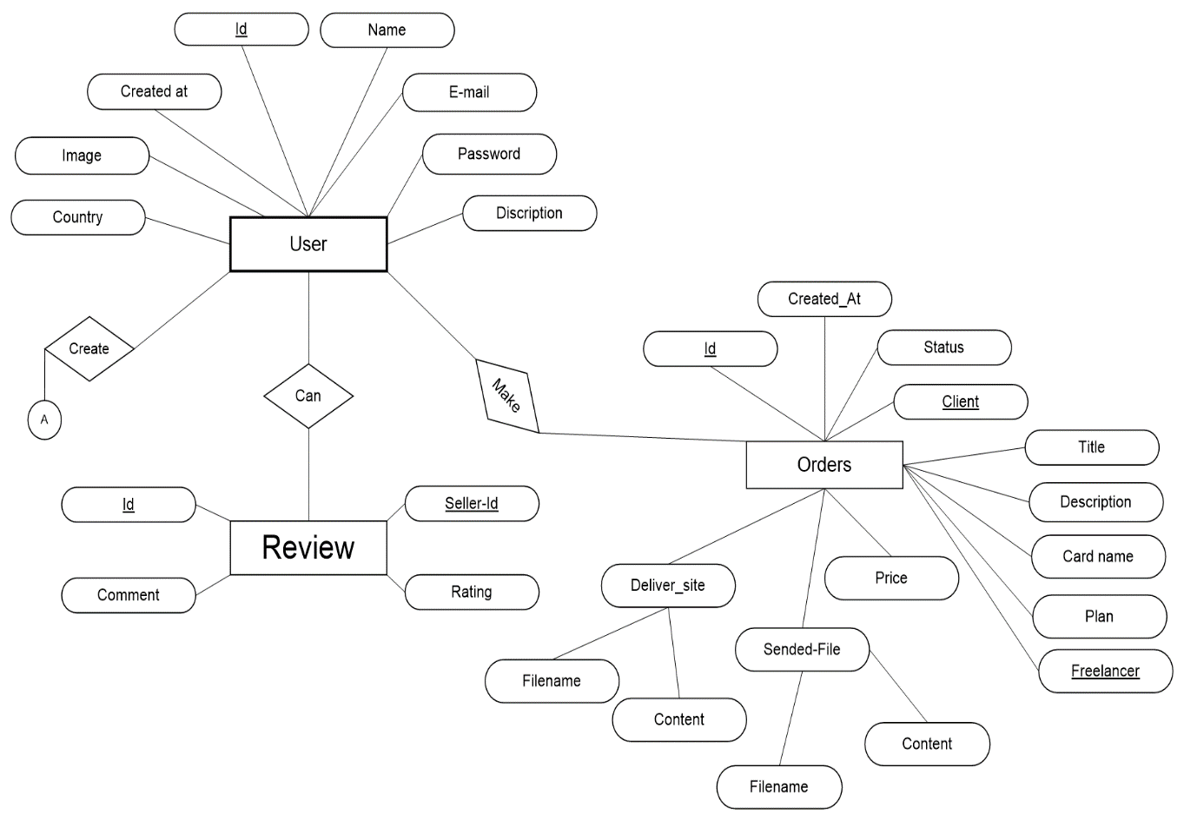

**Admin ER Diagram:**



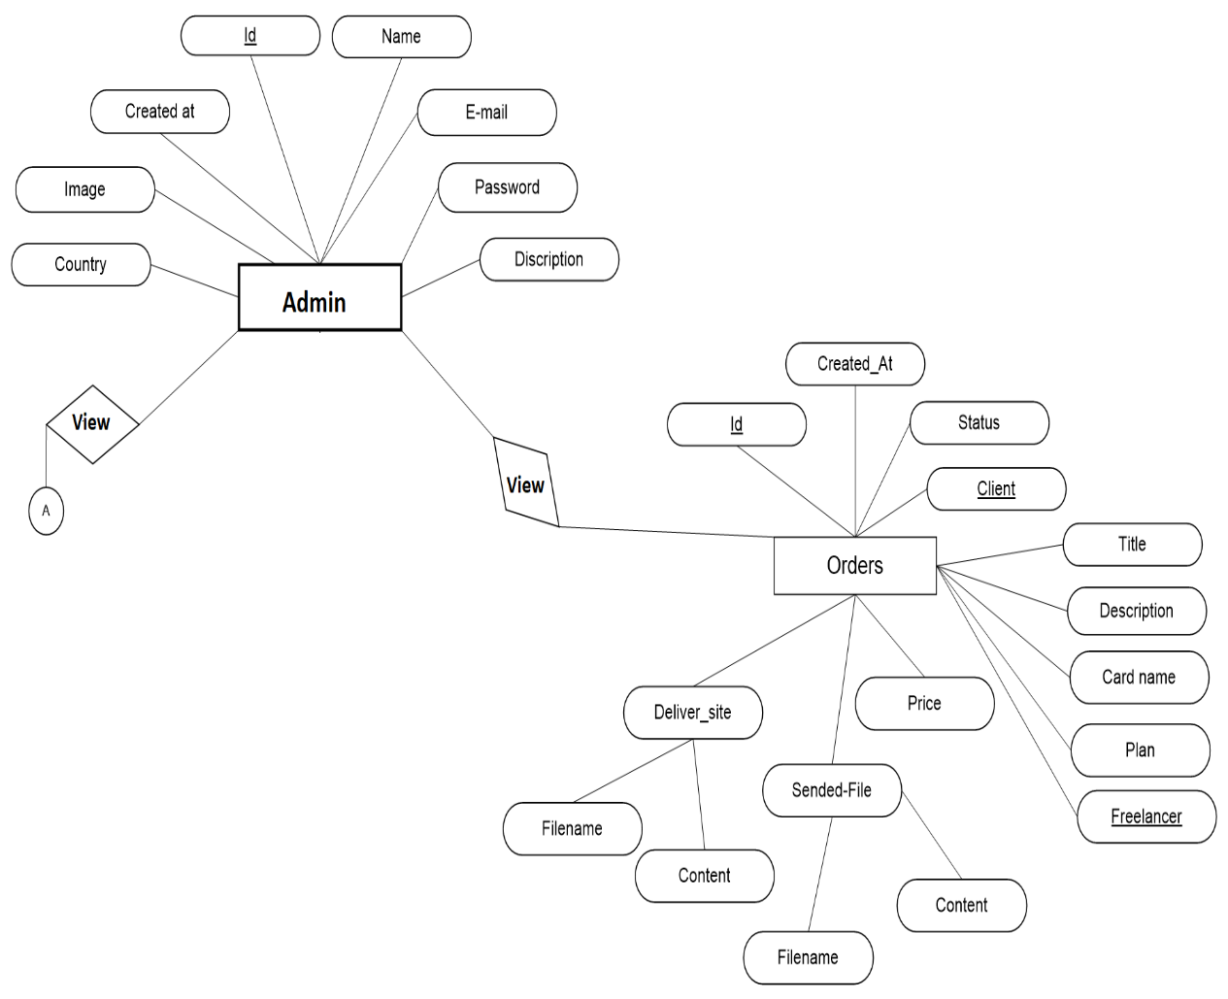

**DATABASE TABLES AND TABLE DESIGN**

**Admin module:**

Here the Admin basically act as our main entity in this entire project. He can view all the customers producers and products which are been the registered in the site and after seeing register customer, producers and products he verifies and then gives approval to the registered things.

**Database Structures:**

Database design is the first step of design activities that is modeled after analysis of data collected at requirements analysis reveals the actual data to be stored and the direction of flow of data. The general objective of database design is to make the information access easy, quick, inexpensive and flexible. In the network environment several users use the system at different levels of authorization; hence the authenticated should data at their authorization level.

**Table Admin:**

This table is used for Login into the Admin side. The fields here are Username, Password.

|  |  |  |
| --- | --- | --- |
| **Field Name** | **Data Type** | **Constraint** |
| Email id | Varchar (20) | PRIMARY KEY |
| Password | Varchar (10) |  |

**SCREENSHOTS**

**TESTING**

**Testing:**

System should not be tested as a single, monolithic unit. The testing process should therefore proceed in stage where testing is carried out incrementally in conjunction with system implementation. Errors in program components may come to light at a later stage of the testing process. The process is therefore an iterative one with information being feed-back from later stage to earlier parts of the process. The various strategies that were used in testing this software were as follows:

* Unit Testing
* Integration Testing
* System Testing
* Validation Testing
* Black Box Testing White Box Testing
* Acceptance Testing

**Unit Testing:**

Individual components are to ensure that they operate correctly. Each component is tested independently, without other system component. This system was tested with the set of proper test data for each module and the results were checked with the expected output. Unit testing focuses on verification effort on the smallest unit of the software design module. This is also known as MODULE TESTING. This testing is carried out during phases, each module is found to be working satisfactory as regards to the excepted output from the module.

**Integration Testing:**

Integration testing is another aspect of testing that is generally done in order to uncover errors associated with flow the flow of data across interfaces. The unit-tested modules are grouped together and tested in small segments, which makes it easier to isolate and correct errors. This approach is continued until we have integrated all modules to form the system as a whole.

**System Testing**:

System testing is actually a series of different tests whose primary purpose is to fully exercise the computer-based system. The following are the of system tests that were carried out for the system.

**Validation Testing**

The validation testing can be defined in many ways, but a simple definition is that, validation succeeds when the software functions in a manner that can be reasonably expected by the end user.

**Black Box Testing**

Black Box Testing is done to find the followings.

* Incorrect or missing functions.
* Interface errors.
* Error in external database access.
* Performance error.
* Initialization and termination error

**White Box Testing**

This allows the tester to

* Check whether all independent paths within a module have been exercised at least once.
* Exercise all logical decisions on their and false sides.
* Execute all loops and their boundaries and within their bounds.
* Exercise the internal data structure to ensure their validity.
* Ensure whether all the possible validity checks and validity checks and validity lookups have been provided to validate data entry.

**ERROR HANDLING:**

An exception is any error condition or unexpected behavior encountered by executing programs. Exception can be raised because of a fault in your code or in code you call, operating system resources not being available, unexpected conditions and common language runtime encounters and so on. Your application can recover from some of these conditions, but not other. While you cannot recover from most runtime exceptions. The runtime creates an exception information table for each executable. Each method of the executable has an associated array of exception handling information in the exception information table. Each entry in the array describes a protected block of code, any exception filters associated with that code, and any exception handler (catch statement).

**FUTURE SCOPE AND FUTURE ENHANCEMENT**

In the due course of time if the user expects more than what this system provides, i.e., if the new requirements are asked to be made then it can easily satisfy by enhancing the system without making much of changes.

Earlier days for customized report they need lots of time, now this project does that work in one click.

In future the User/admin wants to give any changes they can easily give because our project is user friendly and easily accessible and any changes or modification can be done easily.

Well in the phased it can be enhanced with following:

* Live status for work Done.
* Tracking the work status.
* Data security can be enhanced.
* Online payment transaction.

**CONCLUSION**

The developed software is tested with sample data and the output is obtained and they are according to the requirements. The performance of the system is evaluated and is found to be much more efficient than the existing system though it could not be claimed that it is an ideal project. This project provides the customers with the complete details of GoGigs: Freelancing website which they need will meet the primary requirements of the concern

The project is cost-effective and time efficient. It greatly reduces the cost and time consumption of the candidates.

The goals have been achieved by the developed system are

* Users friendly
* New Gigs Updates.
* Information regarding the works
* Client and Freelancer Information.

**BIBLIOGRAPHY**

1. ” Software Engineering”, by Ian Somerville, Sixth Edition, Pearson Education Ltd 2007.
2. “Web Programming”, by ‘Chris Bates’ Wiley Dream Tech India, Second Edition.
3. IEEE SRS Format.
4. Database Management Systems, by NAVATHE, Fifth Edition, Pearson Education 2007.
5. Collection of tellable Tales, by Harrison Annate, Fourth Edition, Pearson Education, 2002.

Websites :

1. <https://tailwindcss.com/>
2. https://www.mongodb.com/ for Database